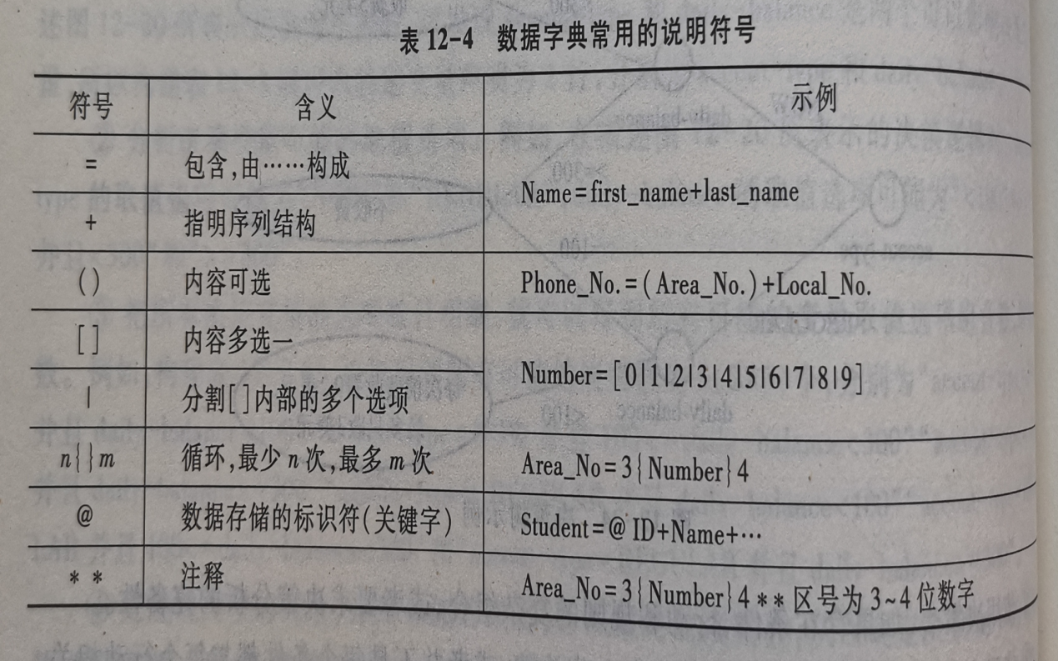**vv**

**PhoneID=AreaID+LocalNO**

**AreaID=0512 | VIOD**

**LocalNO=Head+7{Tail}7**

**//Head=1|2|3|4|5|6|7|8|9**

**//Tail=0|1|2|3|4|5|6|7|8|9**

**Code=1|2|3|4|5|6|7|8|9**

**Head=Code**

**Tail=0|Code**

**Prop=p|r|q|…|w**

**(**

**Nat=…**

**Prop=p+_+Nat (Prop={P_1,p_2,…})  
)**

**Formula=Prop | Formula || Formula | Formula && Formula | ! Formula**